**Installing ARMSim#**

[**https://webhome.cs.uvic.ca/~nigelh/ARMSim-V2.1/index.html**](https://webhome.cs.uvic.ca/~nigelh/ARMSim-V2.1/index.html)

[**https://connex.csc.uvic.ca/access/content/group/ARMSim/SIMWeb/index.html**](https://connex.csc.uvic.ca/access/content/group/ARMSim/SIMWeb/index.html)

The installation process for ARMSim# differs if you're on Windows, Linux, or Mac. You can jump to the appropriate set of instructions by clicking the link below:

* Windows
* Linux
* Mac

**Installing on Windows**

**Step 1: Install .NET Framework 3.5**

You can skip this step if you already have .NET Framework 3.5 installed. You can download .NET Framework 3.5 directly from Microsoft [here](https://www.microsoft.com/en-us/download/confirmation.aspx?id=21). Run the downloaded .exe file, which should perform the full install.

**Step 2: Install ARMSim#**

You can download ARMSim# using [this direct link](https://webhome.cs.uvic.ca/~nigelh/ARMSim-V2.1/Windows/Installer.msi). Run the downloaded .msi file, which should perform the full install. After this install is completed, you should have ARMSim# up and running.

**Installing on Linux**

**Step 1: Install Mono**

You can download Mono [here](http://www.mono-project.com/download/). You may also be able to download Mono via your distribution's package manager. I can confirm that the mono-complete package for the Debian distribution will provide everything you need for Mono.

**Step 2: Download and Unzip Slightly Modified ARMSim#**

Download the zipfile [here](https://kyledewey.github.io/comp122-fall17/resources/installing_armsim/armsim_linux.zip). Unzip the zipfile as you normally would in some location you can easily access. The rest of these instructions assume you unzipped this in /home/myself/comp122, resulting in a armsim folder being created underneath comp122.

**Step 3: Run ARMSim# with Mono**

Open a terminal window. Change to the directory that contains your unzipped ARMSim#. For example, if you saved this in /home/myself/comp122, you should issue the following command:

cd /home/myself/comp122/armsim

From here, you should be able to run ARMSim# with:

mono ARMSim.exe

Every time you run ARMSim# in the future, you will need to follow this step (3). You only ever need to install Mono and unzip ARMSim# once.

**(Optional) Step 4: Make a Script to Run ARMSim# More Easily Next Time**

You can write a script that can more easily run ARMSim# than in the previous step. Specifically, this step avoids the need to use a terminal each time you want to run ARMSim#.

**Installing on Mac**

Unfortunately ARMSim# no longer works on Mac OS X. The best alternatives are to either set up BootCamp on the Mac to run Windows (and use the Windows version of ARMSim# of course), or install virtual machine software to provide Linux or Windows as the guest operating system.

To address this problem, Dr. Kyle Dewey had setup a virtual machine image which already has ARMSim# installed. The virtual machine acts as a self-contained computer (specifically a Linux-based computer) that already has ARMSim# installed. This approach can be used on both Windows and Linux as well as Mac, but it's probably easier to use the Windows/Linux-specific instructions if you can use them.

**Step 1: Install VirtualBox**

VirtualBox is software that emulates a computer within a computer. You can download it [here](https://www.virtualbox.org/wiki/Downloads). Be sure to pick “OS X hosts” in the menu, which will download a Mac-specific version of VirtualBox.

**Step 2: Download a Custom Virtual Machine Image**

Download the machine image [here](https://www.dropbox.com/s/a719v7zhrsjp1k5/armsim.ova?dl=0) (**warning:** this file is 1.57 GB in size, so the download may take awhile).

**Step 3: Import the Virtual Machine Image**

Open VirtualBox. Go to File -> Import Appliance, then choose the file you downloaded in the previous step. Accept all the default settings, and click “Import”. It may take several minutes for VirtualBox to complete the import.

**Step 4: Run the Virtual Machine**

If the import in the previous step was successful, you will see armsim displayed on the left of the VirtualBox window, along with the word “Aborted”. While the “Aborted” part looks scary, this is ok; this is merely an artifact of how I prepared the image. Click on armsim, then click Start (the green arrow). VirtualBox may then ask you about selecting a virtual optical disk file; click Cancel in case this happens.

**Step 5: Login to the Virtual Machine**

Eventually you will see a login screen like the one below:

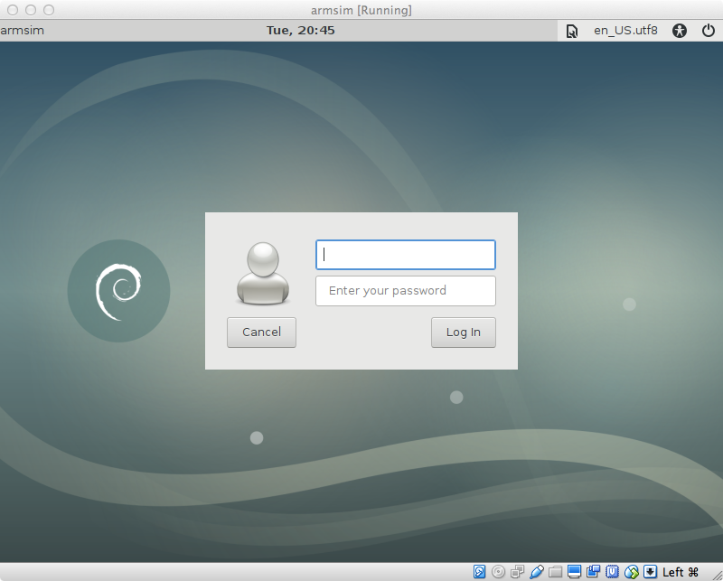

You can login to the virtual machine with the following credentials:

* Username: student
* Password: studentpassword

(For the Linux-savvy, the password for the root user is rootpassword.)

**Step 6: Open ARMSim#**

Double-click on the ARMSim.sh file on the desktop. This will load ARMSim#.

**Step 7: Downloading and Editing Files**

While VirtualBox runs in a window, this window is itself a self-contained computer. This is a little awkward at first, as you cannot easily do things like copy-and-paste between VirtualBox and anything else (though you can still copy-and-paste within VirtualBox). It also can be challenging to get files into VirtualBox. (For the tech-savvy, you *can* get these features working, but it requires a significant amount of effort.)

For downloading files, the machine image comes complete with its own Web browser (Applications -> Internet -> Firefox ESR).   
For editing files, emacs (Applications -> Development -> GNU Emacs 24 (GUI)) has been installed.